**Name: Shabana Ajamal Hannure**

**U-ID: U80532141**

**Hospital Database Design Document**

**Version 1.0 Revision 1**

**Submittal Date: 9/25/2021**

**Version History**

|  |  |
| --- | --- |
| **1.0 Rev 1** | **1st release doc** |
| **1.1 Rev 1** | **Updated document with correction**  **9/25/2021** |
|  |  |

**Table of Contents**

|  |  |
| --- | --- |
| **Purpose** | **4** |
| **Narrative** | **4-5** |
| **Entities** | **6** |
| **Attributes** | **6** |
| **Actors and Roles** | **6-7** |
| **Business Rules** | **8** |
| **Entity Relationship Diagram** | **9** |
| **Enhanced Entity Relationship Diagram** | **10** |
| **Relational Schema** | **11** |
| **Database Diagram** | **12** |

**Purpose**

The purpose of this document is to develop and keep track of changes taking place in Hospital database. Some of the major process to be tracked are:

1. Records of Patients who come to take treatment
2. Record of items to be used in treatment.
3. Treatment record of patient
4. Nurse records
5. Physician records
6. Wards, bed and availability record.

**NARRATIVE**

The hospital administrator wants to create a database to track nurse assignments to their wards and nurse interactions with their patients, patient admissions by their doctors and treatments administered by doctors to their patients, bed assignments for each patient and items charged to patients during their stay. Administrator wants to record each nurse’s name and address, phone and alternate phone, email and the medical specialties he or she is certified. Some nurses supervise one or more other nurses. No nurse is supervised by more than one nurse, and some nurses are unsupervised.

Each ward at the hospital has a designated number, descriptive name, physical location and phone number. Each ward has at least one nurse assigned to it. A nurse is assigned to at least one ward and rotates assignments among other wards. The assignment is tracked by the specific date and the hours worked in the assigned ward by each nurse on that date.

In addition to nurse assignments, each ward also has a charge nurse. The charge nurse is the custodian of the medical records for the ward. Not all nurses act in this capacity, but those that do are in charge of only one ward, and a ward only has one charge nurse.

A ward consists of hospital beds. The beds are inventoried to a specific ward. Information on beds including their size (small, large, extra-large) and their type (elevated electrically or manually) and if they are available to be assigned to a patient. Most of the beds are large and manual (this is the default setting). The data entry (checks) for beds is limited to S, L, XL for size; E or M for type; O for occupied and A for available. Availability defaults to occupied to avoid double booking by mistake. All of these value formats are set by rule or check.

When a patient is admitted to the hospital they are assigned to a specific bed. Not all beds are available for use all the time, and a bed may not be assigned to more than one patient. In this database we are only tracking bed assignment history and not bed occupancy or availability.

Workflow: The admitting official conducts a review of all beds to determine which beds are available to assign to a patient.

Information on patients is recorded: name, gender, dob, address, phone, alternate phone, email. The patient’s calculated age is also tracked.

The date the patient is admitted to the hospital, the admitting doctor, the date the patient is discharged, and discharging doctor are also tracked.

Some doctors admit patients while others do not. Doctor information tracked: name, address, phone, alternate phone, email and their medical specialties.

The hospital tracks the treatments administered to patients and the treating doctor. Treat­ments are tracked by name, description, and charge. The hospital also tracks the date and time of each treatment administered and the results. Some doctors treat patients while others do not.

A given patient may receive no treatments or may receive many, and some patients may receive their treatments from more than one doctor. Some treatments have yet to be used while others have been used often.

In addition to treatments, patients incur other charges for items used during their stay. The hospital tracks these charges as “items” and stores information on what items have been charged to which patients, based on date and quantity. Information that is to be stored for each item includes the item name and charge. All patients incur at least one charge for consumable items used during their stay. Some items are used often while items may be new or unusual in nature and might rarely or never be charged to any patients.

Lastly, the hospital tracks nurse patient care. Each nurse-patient care interaction is an event. There are several types of events: wellness check, medication, food service, assistance, treatment admin, and “other.” Given the number of shifts and ward rotations, a patient will typically be seen by more than one nurse during their stay, and a nurse most likely will interact with the same patient over several events during a single shift.

**Actors &Roles:**

**Nurses**: Assigned to the ward

**Physicians**: Administer Treatment

**Patients**: Receives treatment

**Items**: Get charged by patients

**Beds**: assigned for each patient

**Wards**: Assigned to the patients

**Treatment**: administered by doctors to their patients:

**charge** **nurse**: The charge nurse is the custodian of the medical records for the ward

**Entities**:

Nurses

Nurse Assighnment

Nurse Certification

Nurse Patient

Physicians

Physician Speciality

Patients

Items

Item Charge

Beds

Wards

AdmitDischarge

Treatment

Treatment Administration

**Entities w/ Nested Attributes:**

**Nurses**:

Name

Address

Phone

Email

Certifications

Supervisor

Nurse_Patient

Event

Type

Date

Time

Patient ID

NurseID

**Nurse Assignment**

NurseID

WardID

Date

Hours

**Physicians**:

Name

Address

Phone,

Email

AdmittingDoctor

Discharging Dr.

Discharge Date

Physician Speciality

DoctorID

Speciality

**Patients**:

Name

Gender

DOB,

Address,

Phone,

Email

Age

BedNo

**Items**:

Item name

Charge

Item No

Item Charge

Charge No

Date

Quantity

Patient No

ItemNo

**Beds**:

Size

Type

Bed No

WardNo

**Wards**:

Ward NO.

Physical Location

Phone Number

Charge_Nurse

**Treatment**:

Treatment No

Treatment Name

Charge

Description

**Business Rules:**

**Nurses**: Some nurses supervise one or more other nurses. No nurse is supervised by more than one nurse, and some nurses are unsupervised.

**Physicians**: Some doctors admit patients while others do not, Some doctors treat patients while others do not.

**Patients**: a patient will typically be seen by more than one nurse during their stay

**Items**: All patients incur at least one charge for consumable items used during their stay.

**Beds**: a bed may not be assigned to more than one patient

**Wards**: Each ward has at least one nurse assigned to it. A nurse is assigned to at least one ward and rotates assignments among other wards,’

each ward also has a charge nurse.

**Treatment** patient may receive no treatments or may receive many, and some patients may receive their treatments from more than one doctor.

**ERD:**

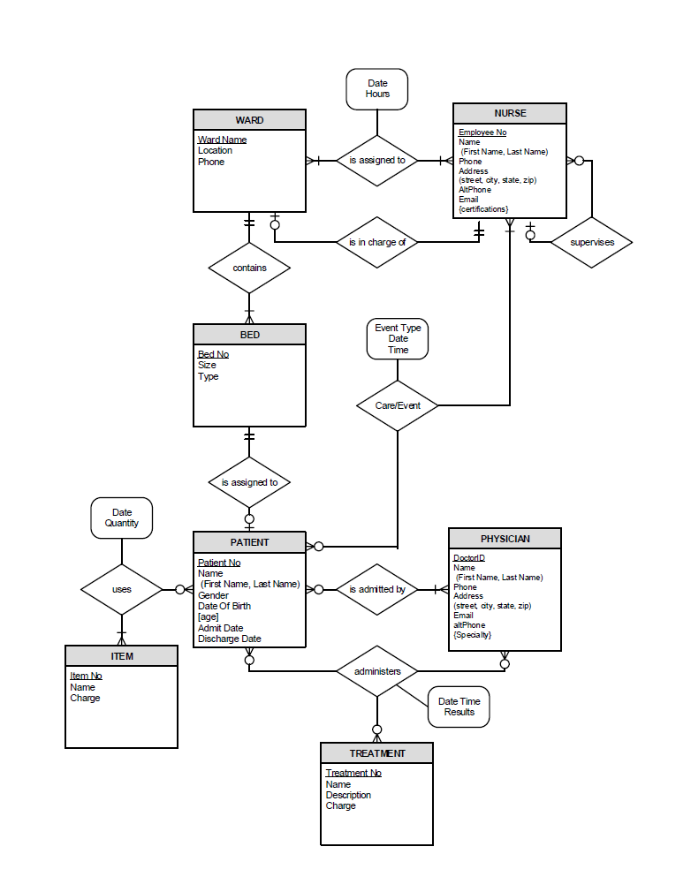

**EERD:**

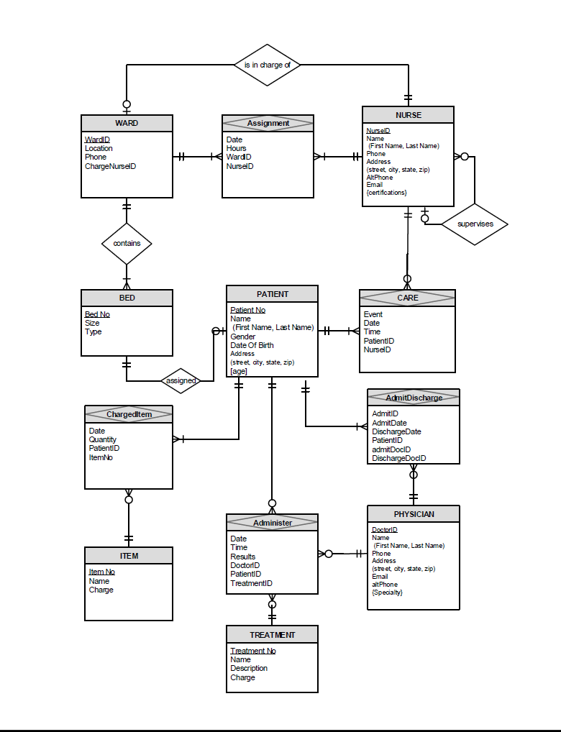

**RELATIONAL SCHEMA:**



|  |  |  |  |
| --- | --- | --- | --- |
|  |  |  |  |

**Database Diagram:**

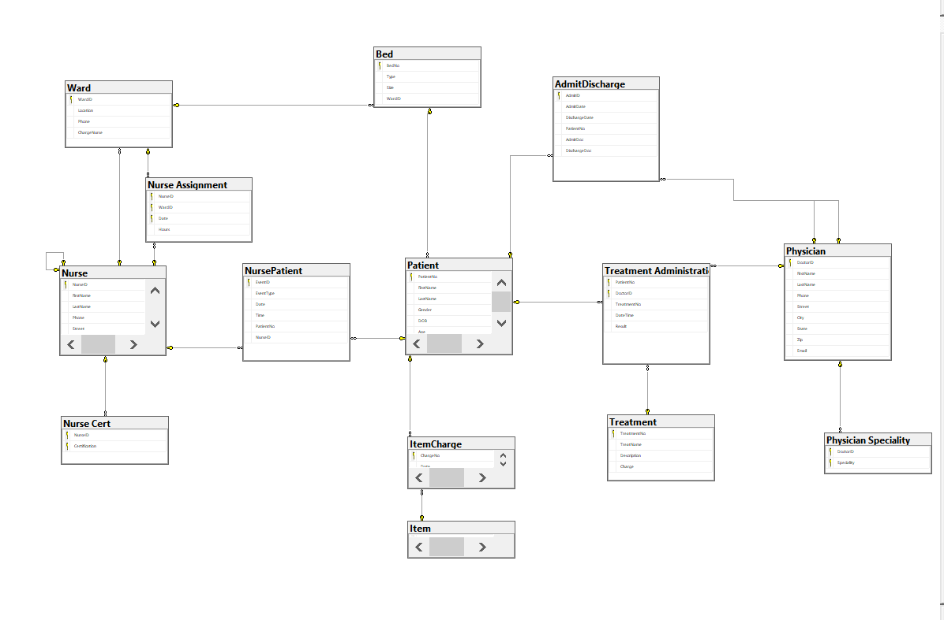

**Student ID: U80532141**

**Name: Shabana Ajamal Hannure**